**Assignment**

**Report of OS**

1.Ubuntu

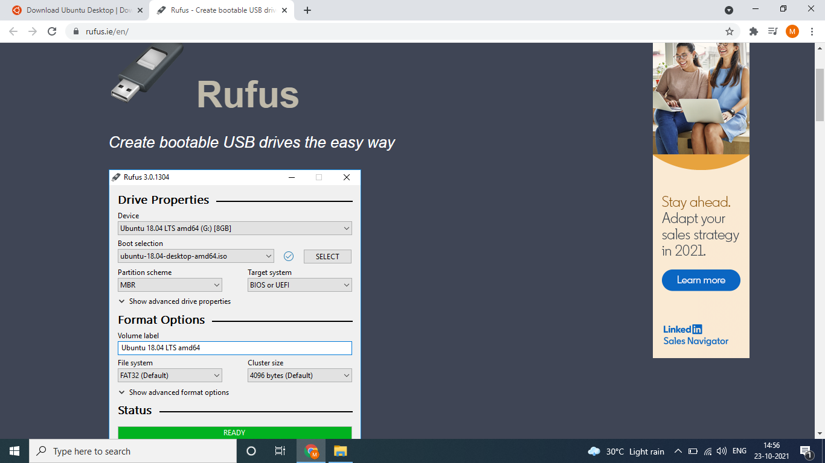

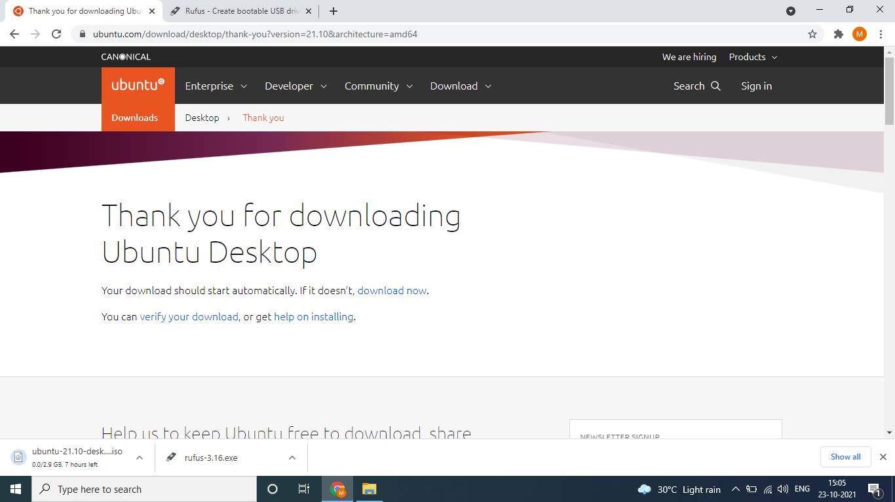

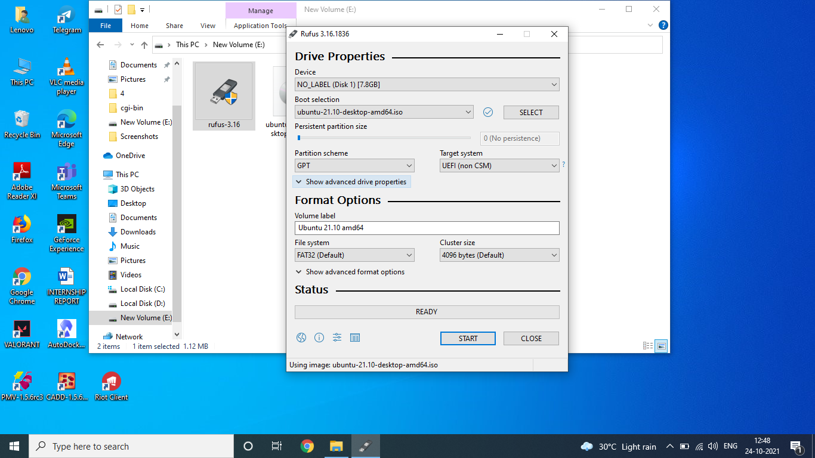

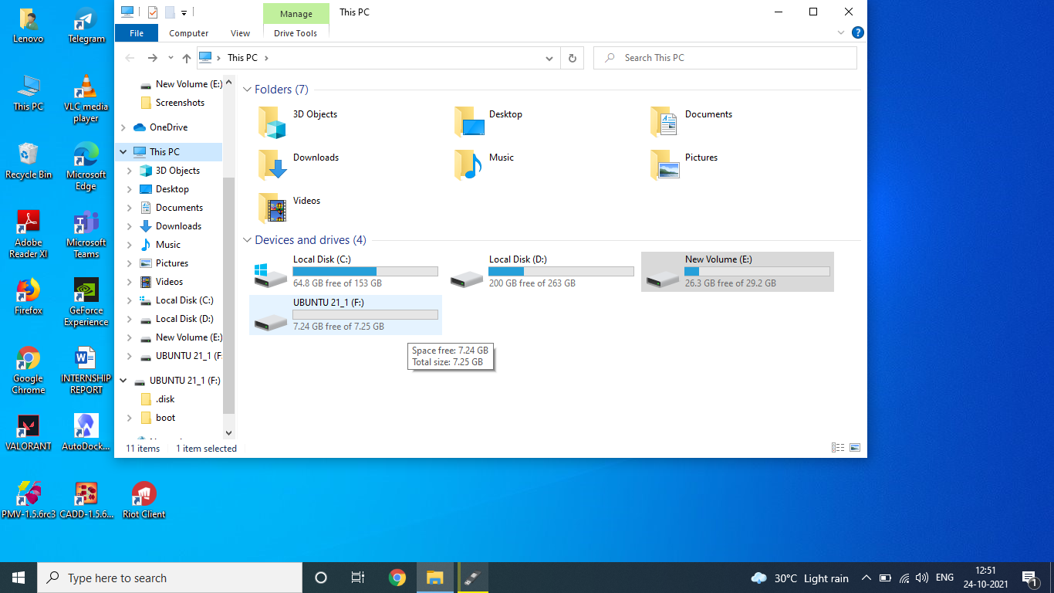

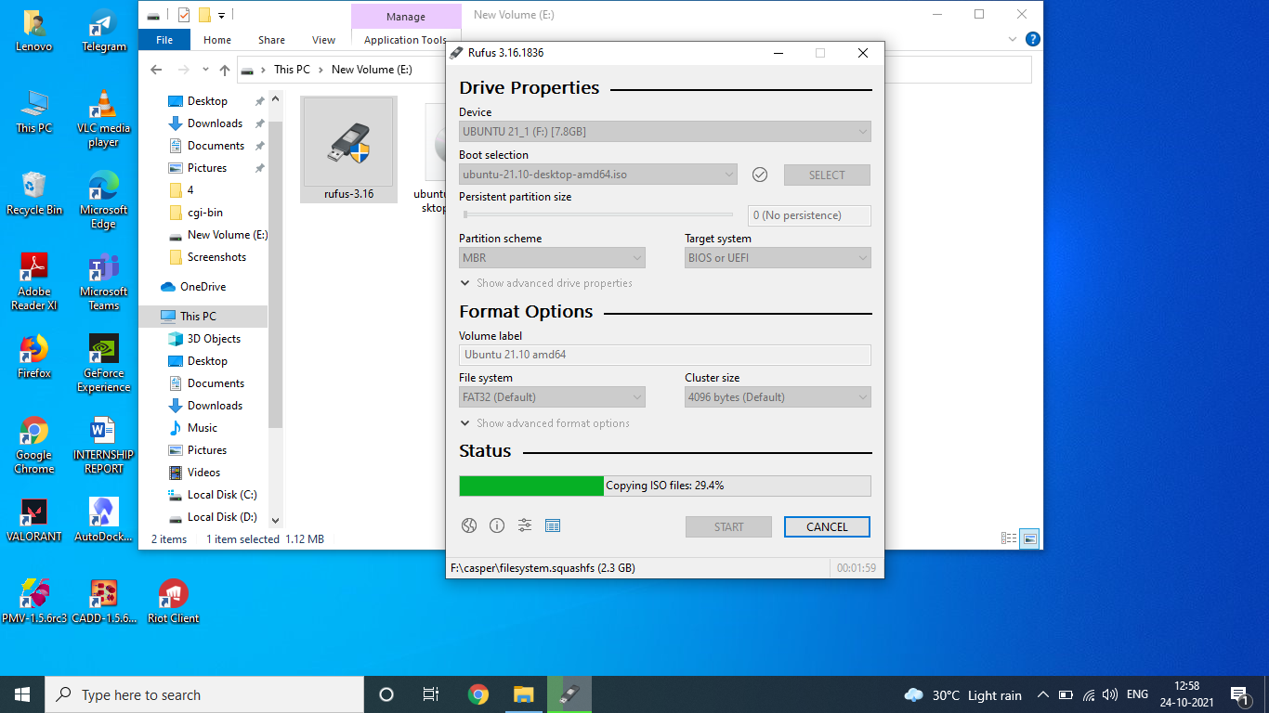

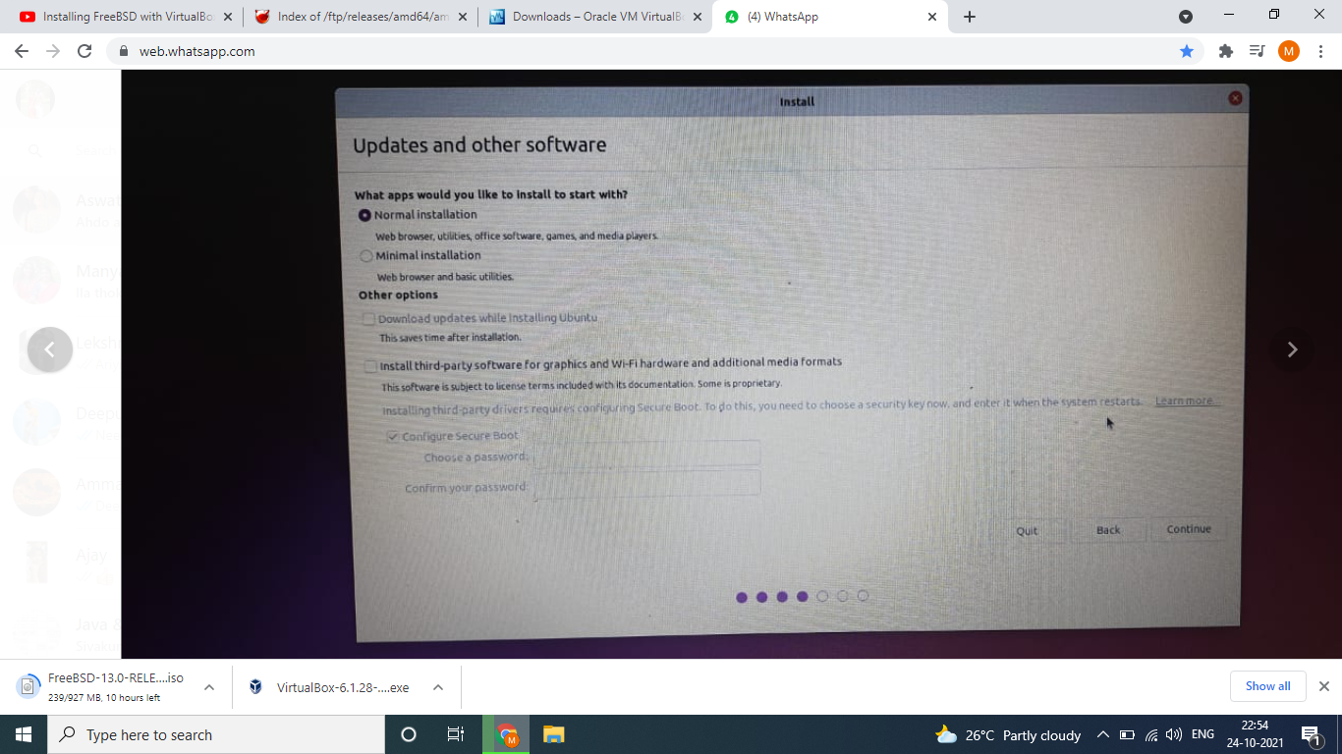

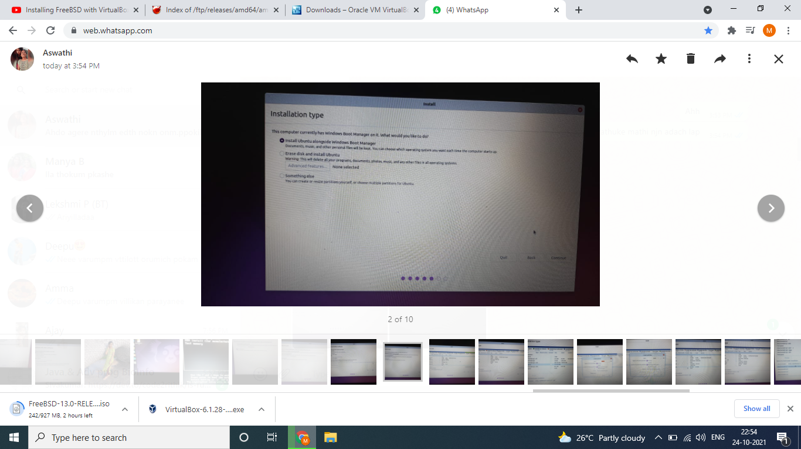

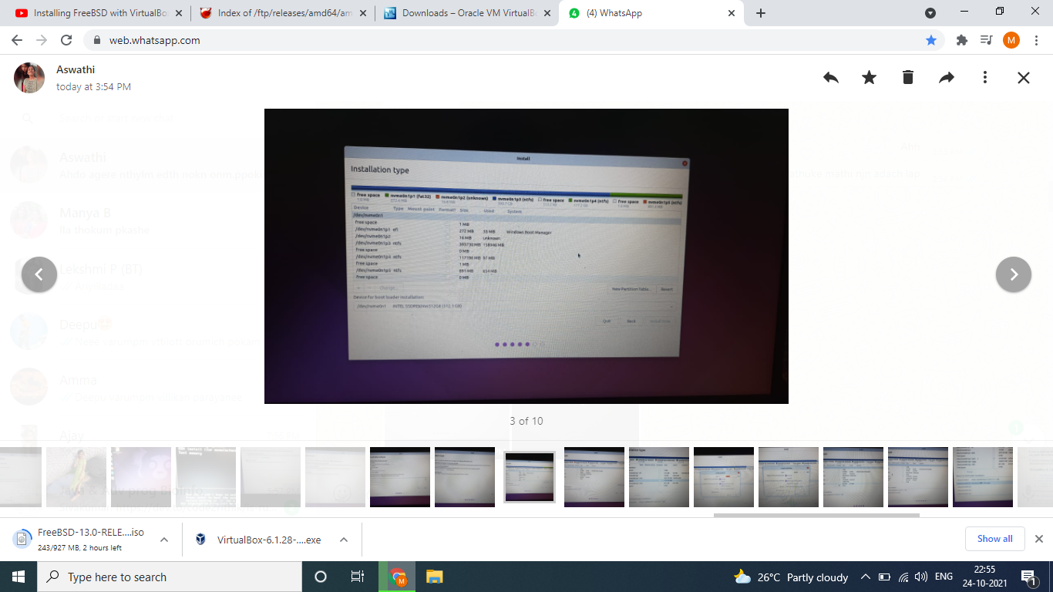

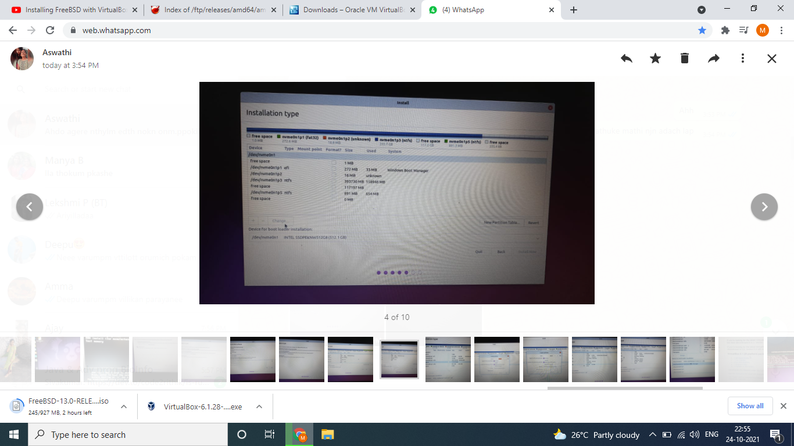

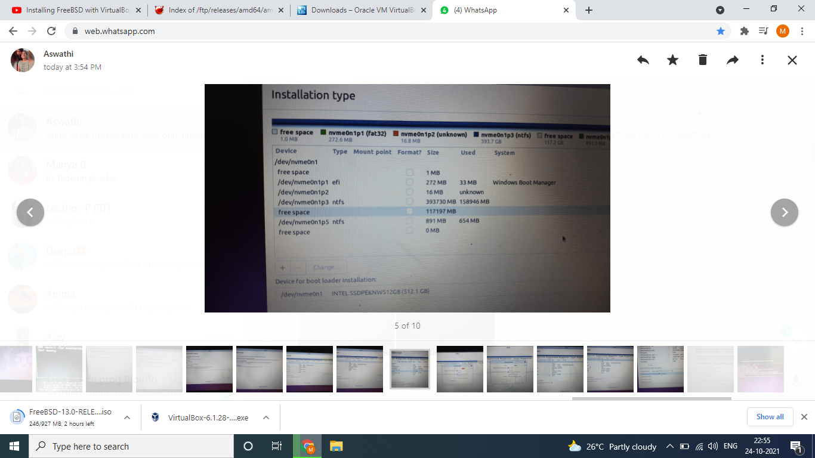

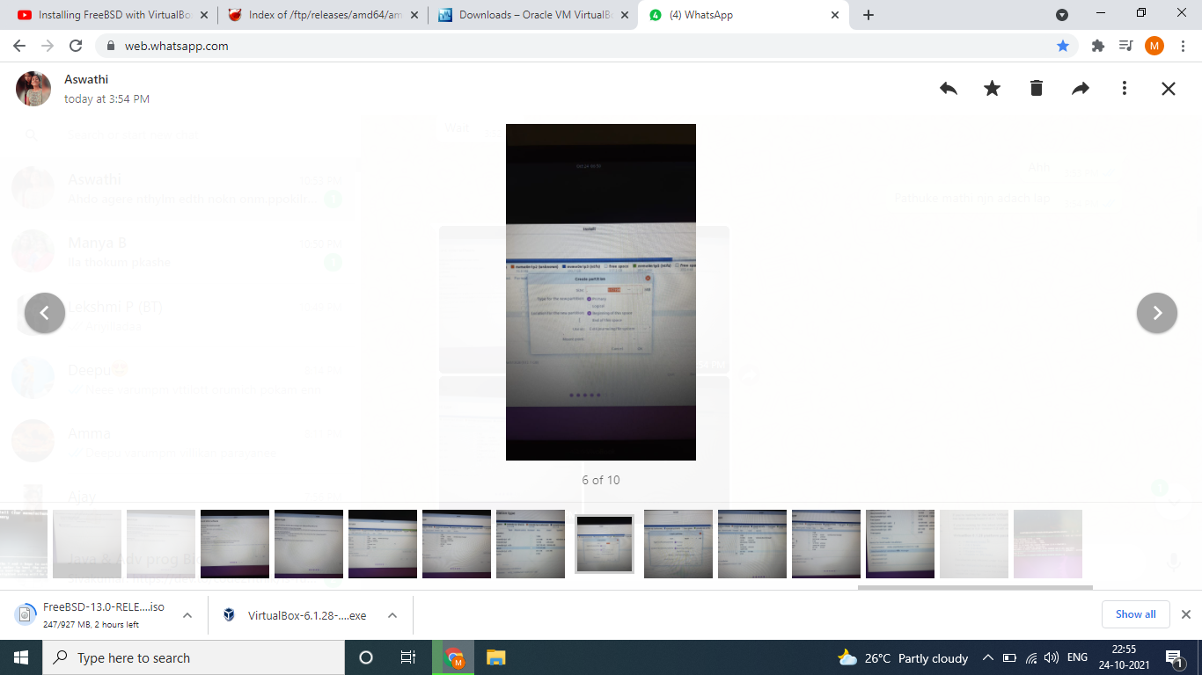

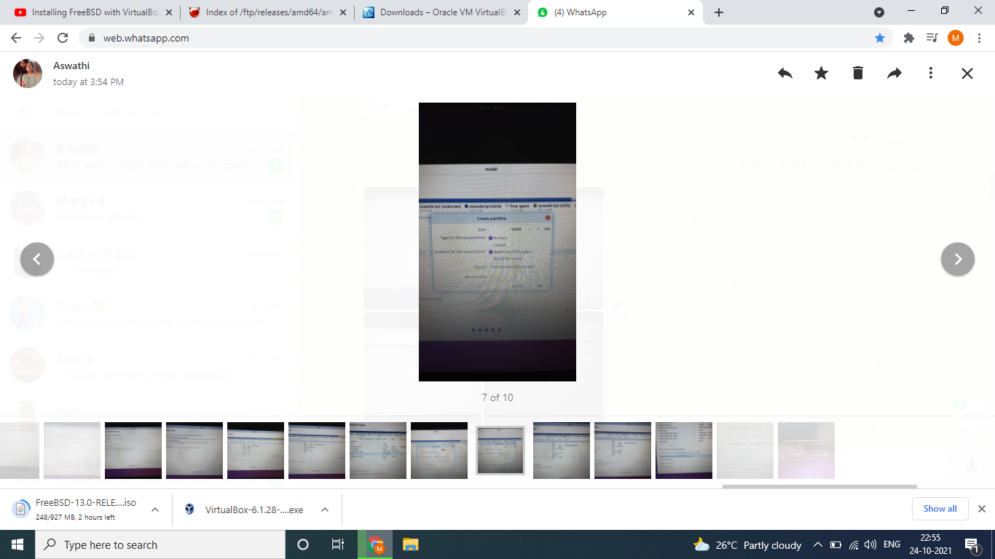

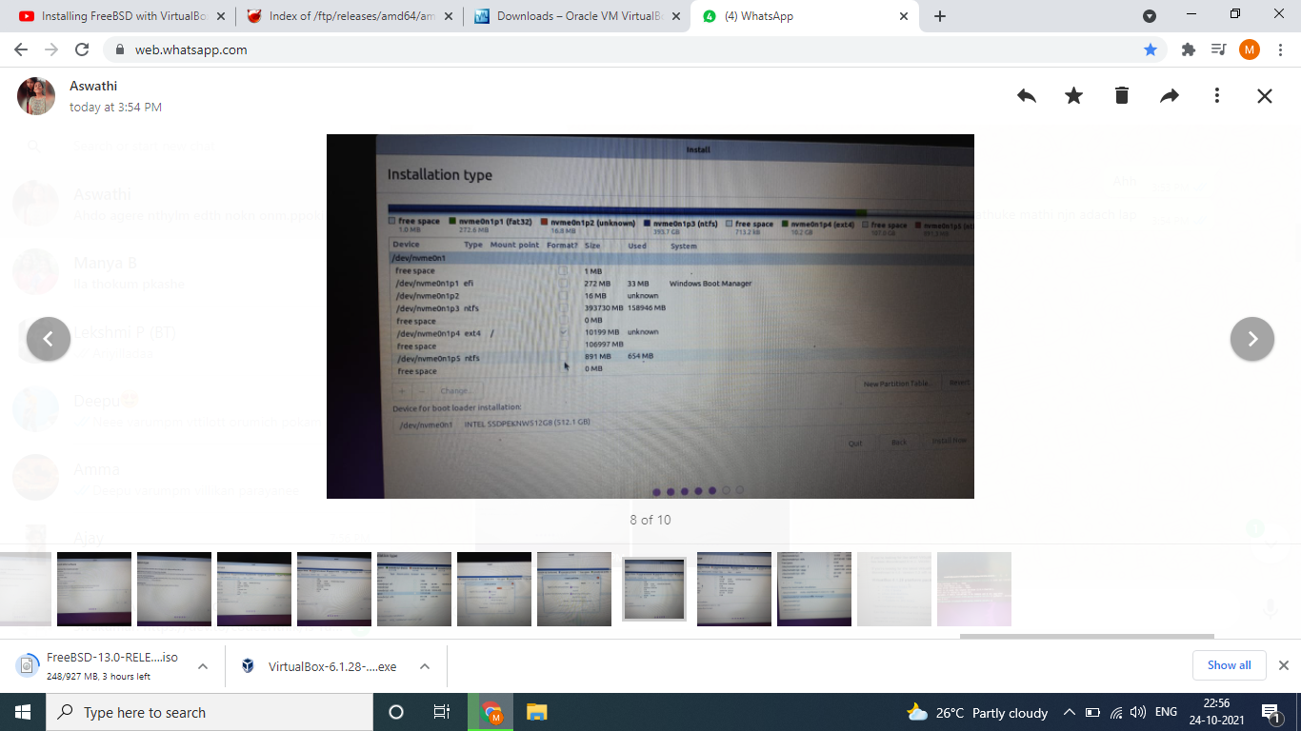

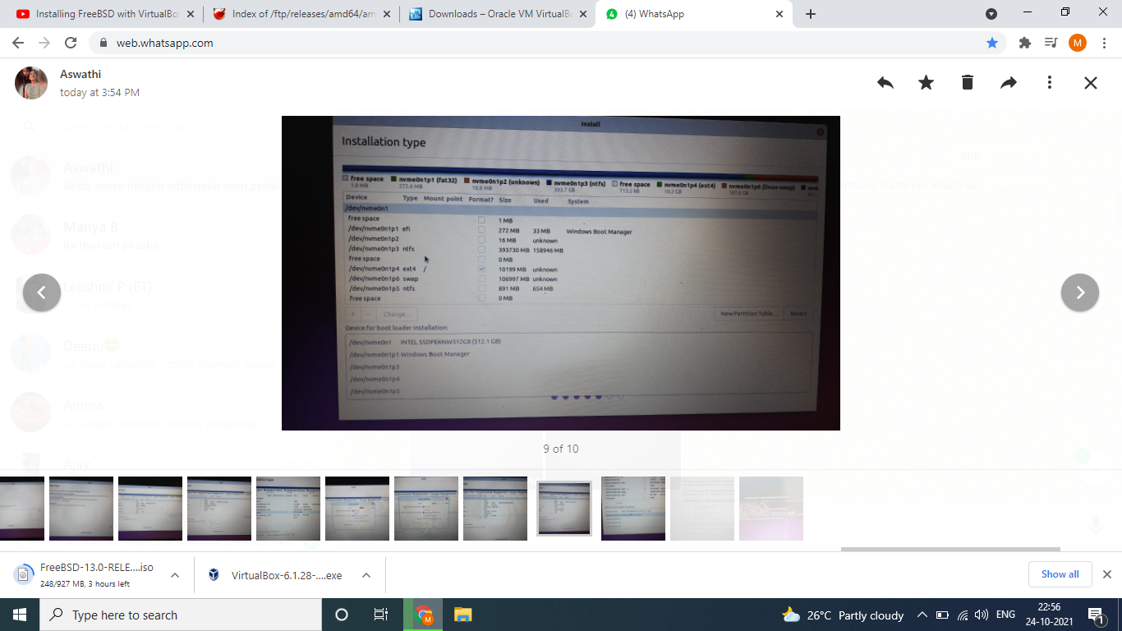

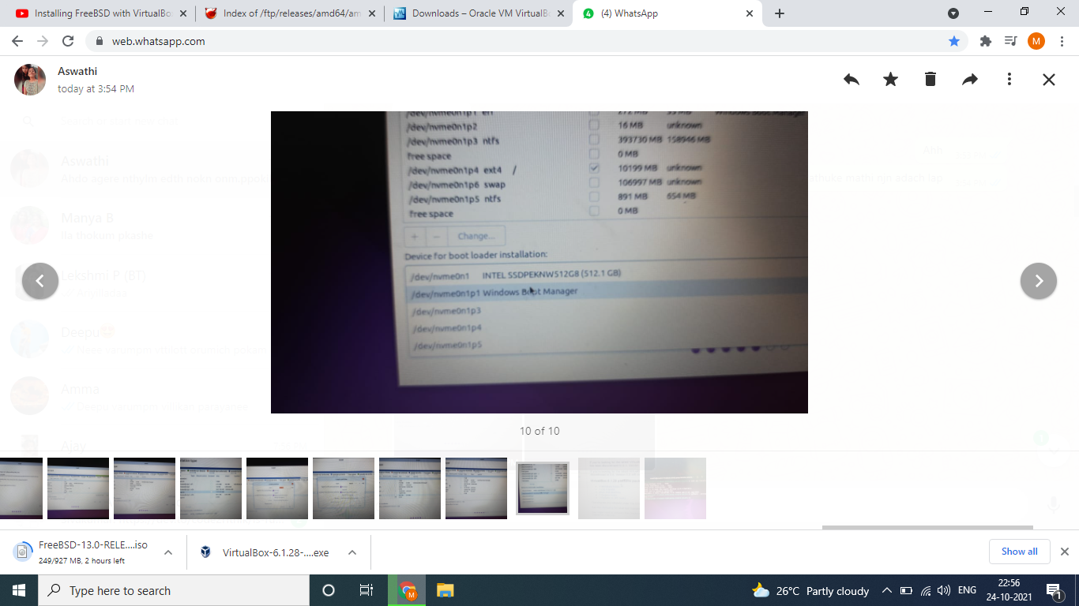

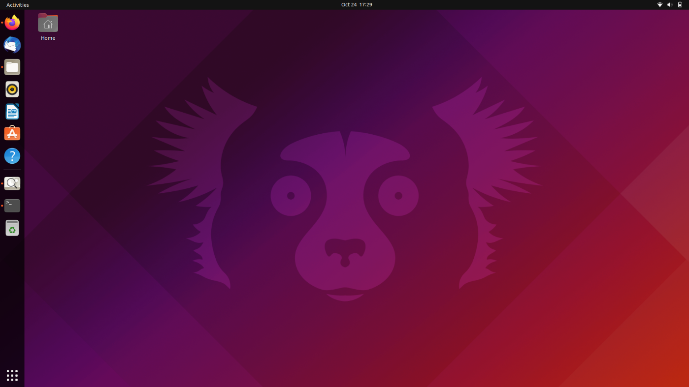

**2.BSD**

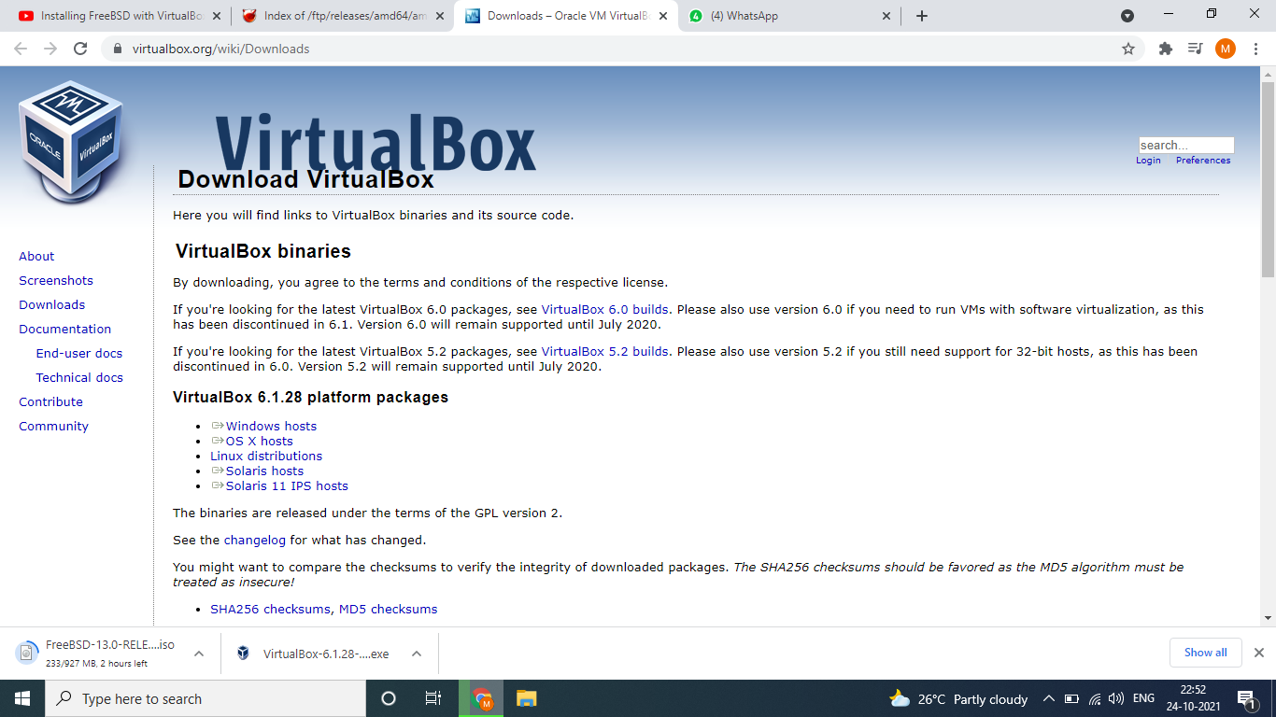

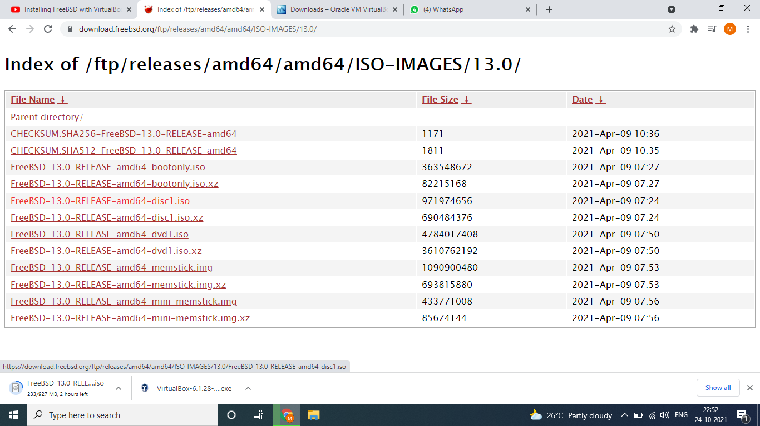

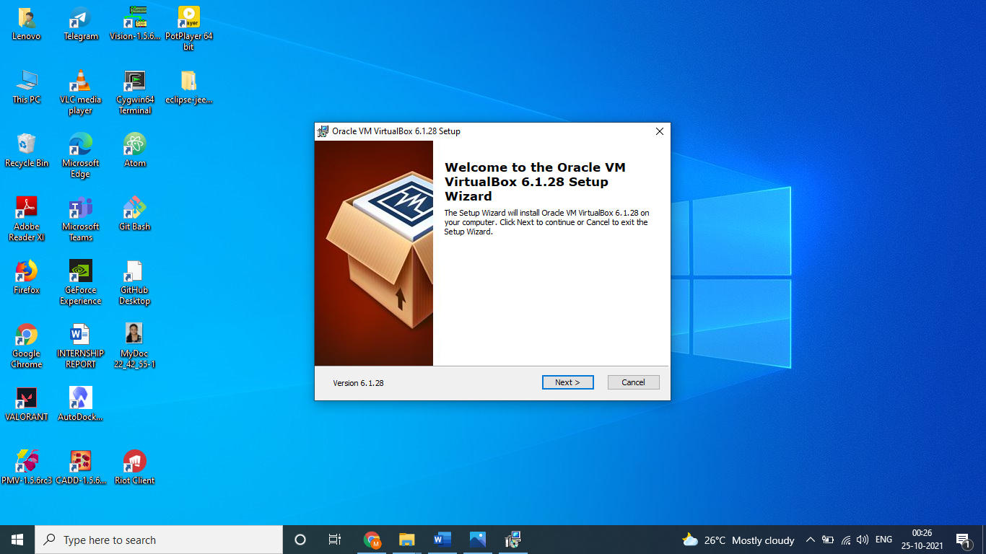

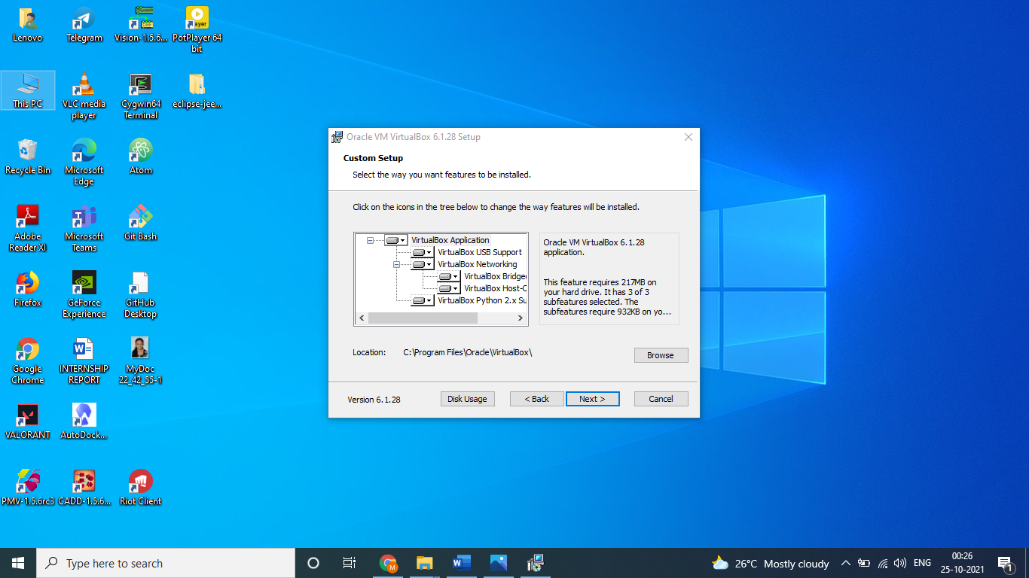

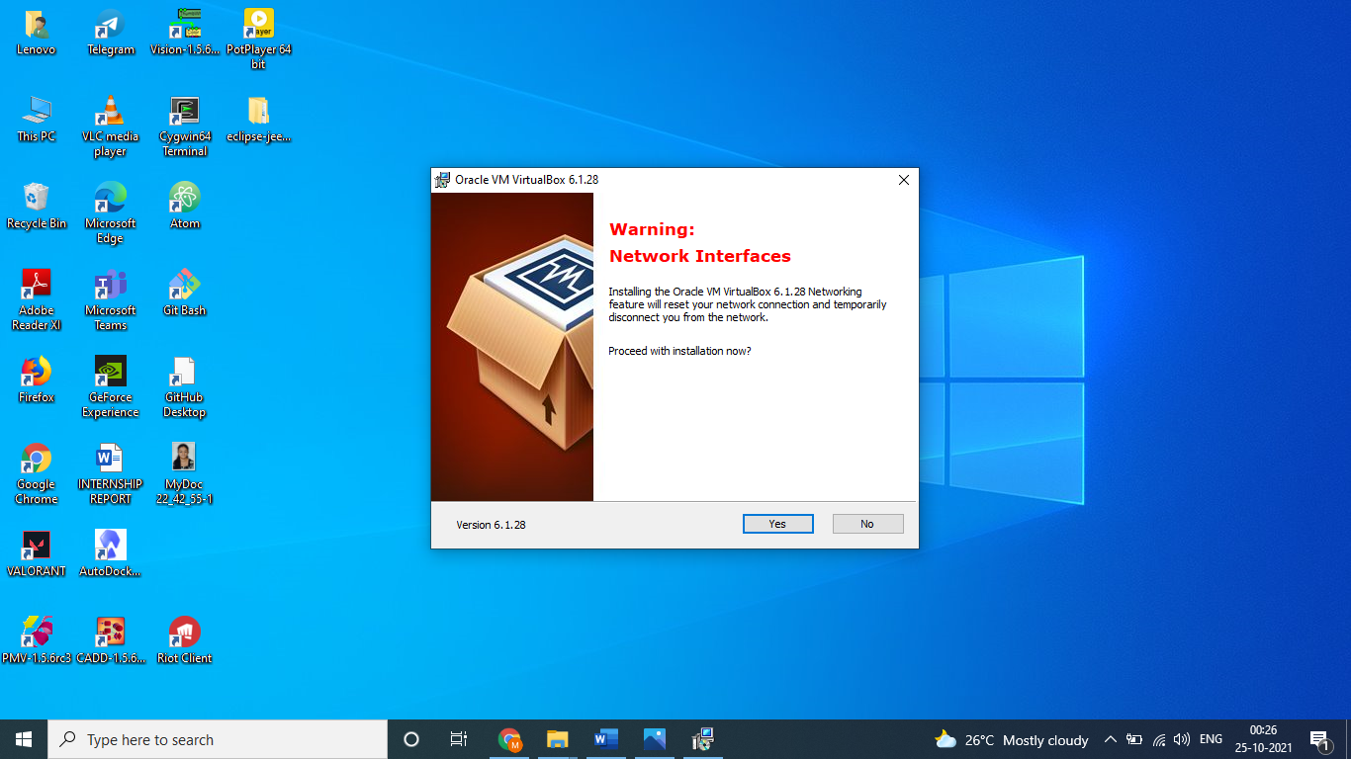

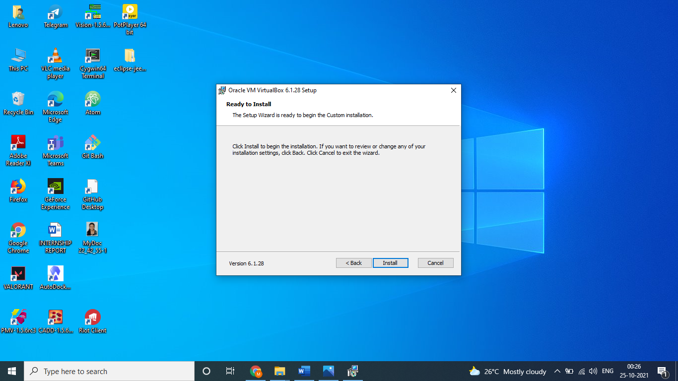

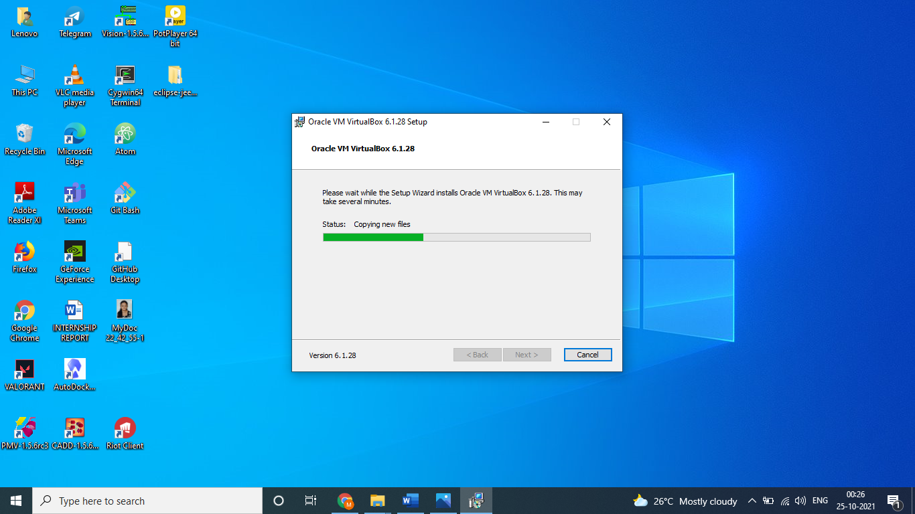

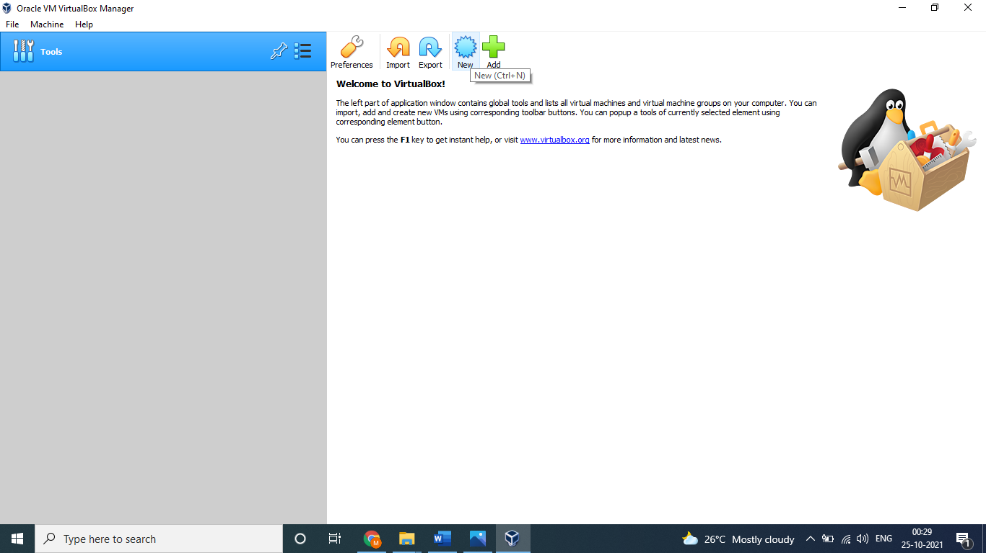

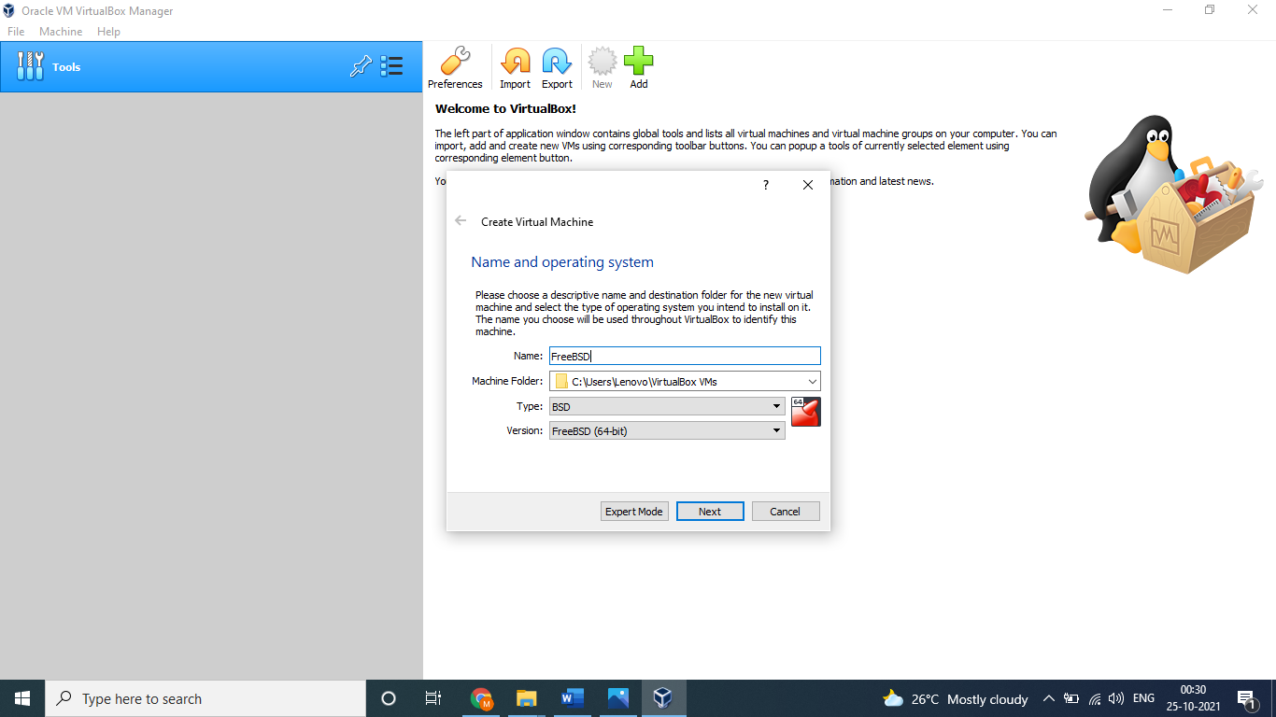

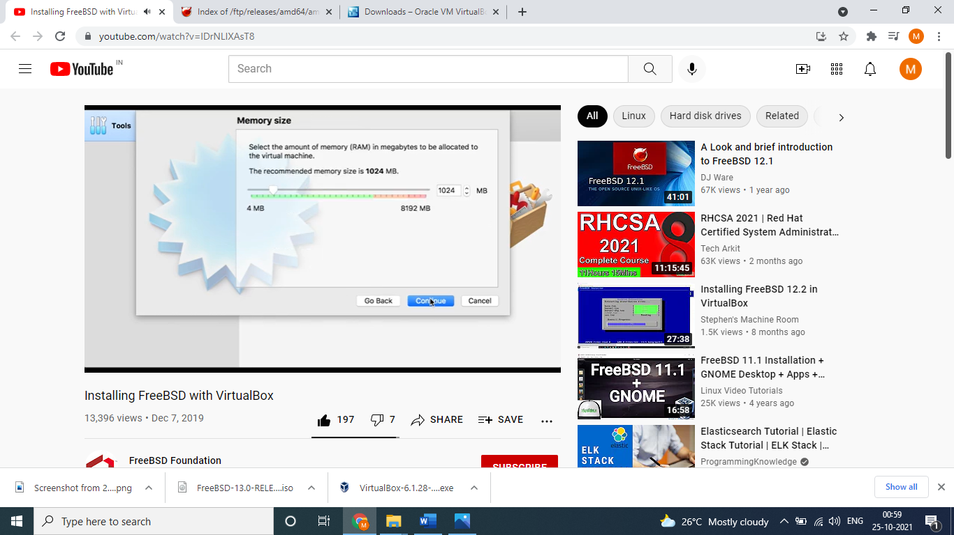

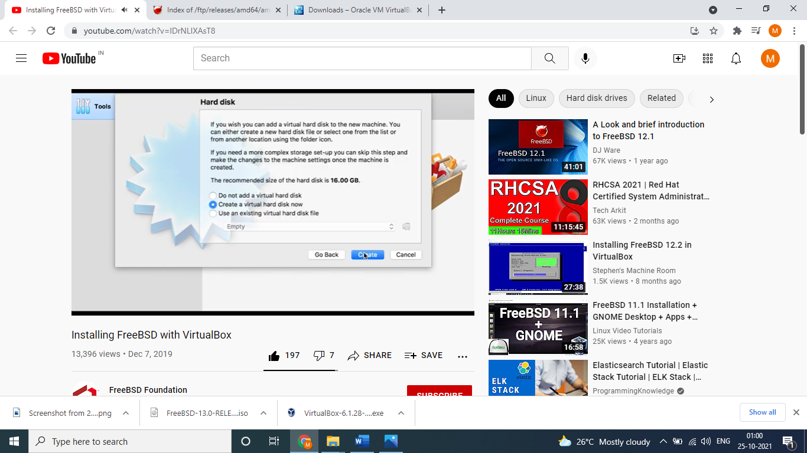

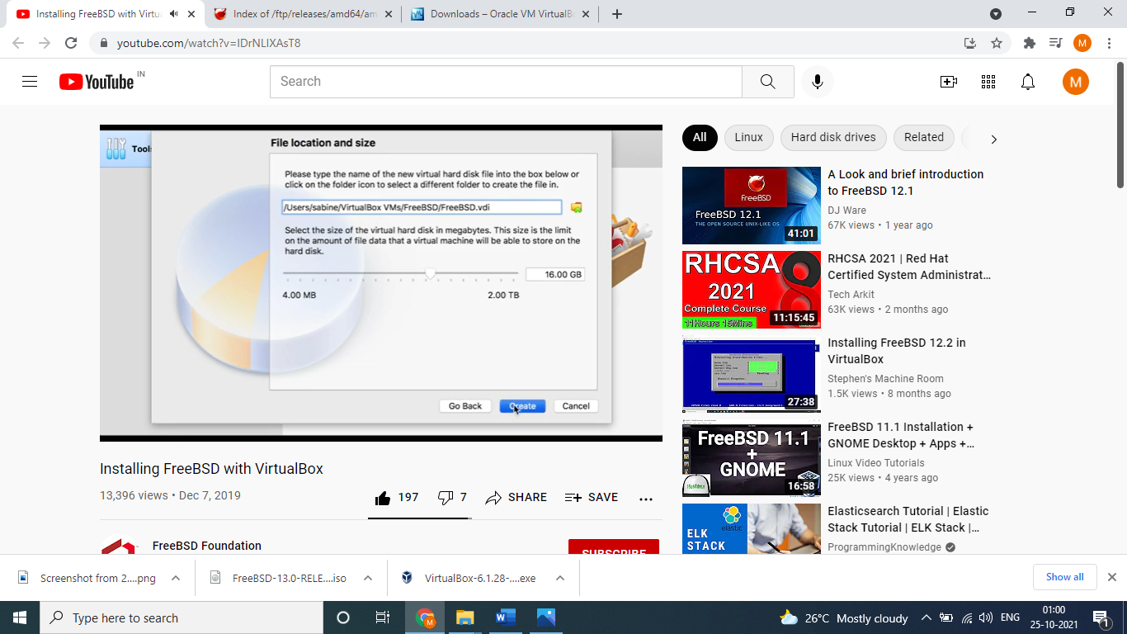

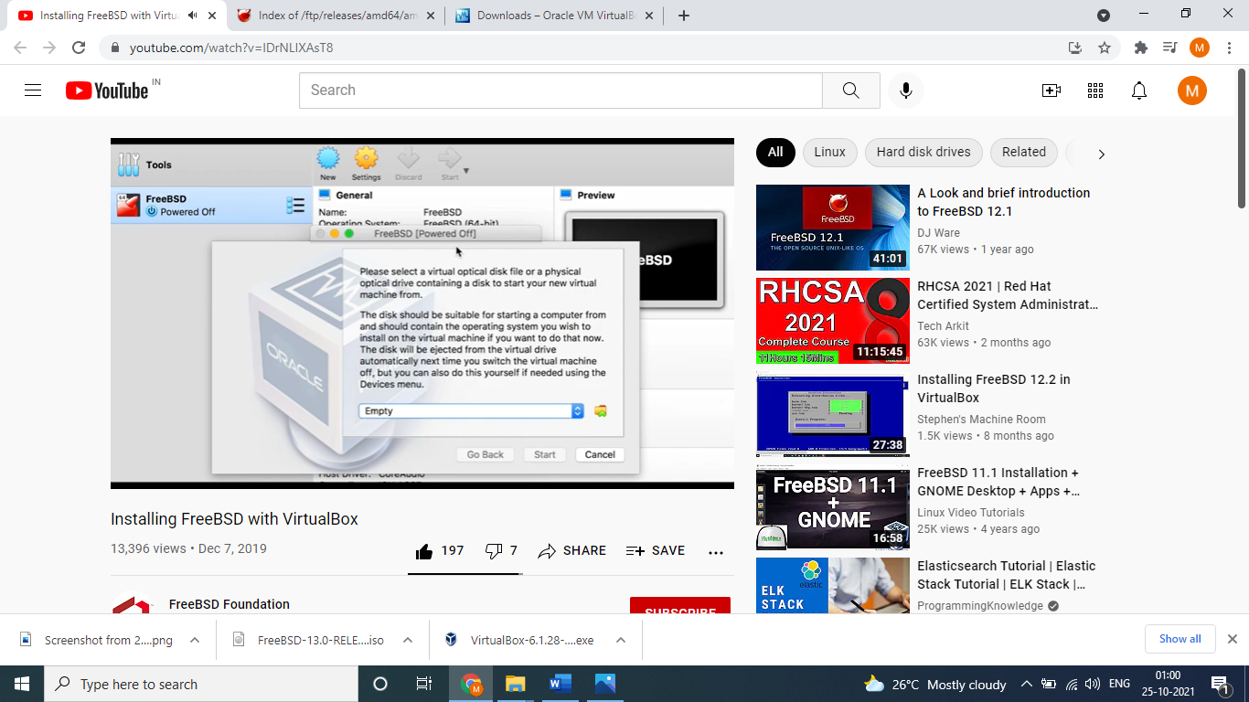

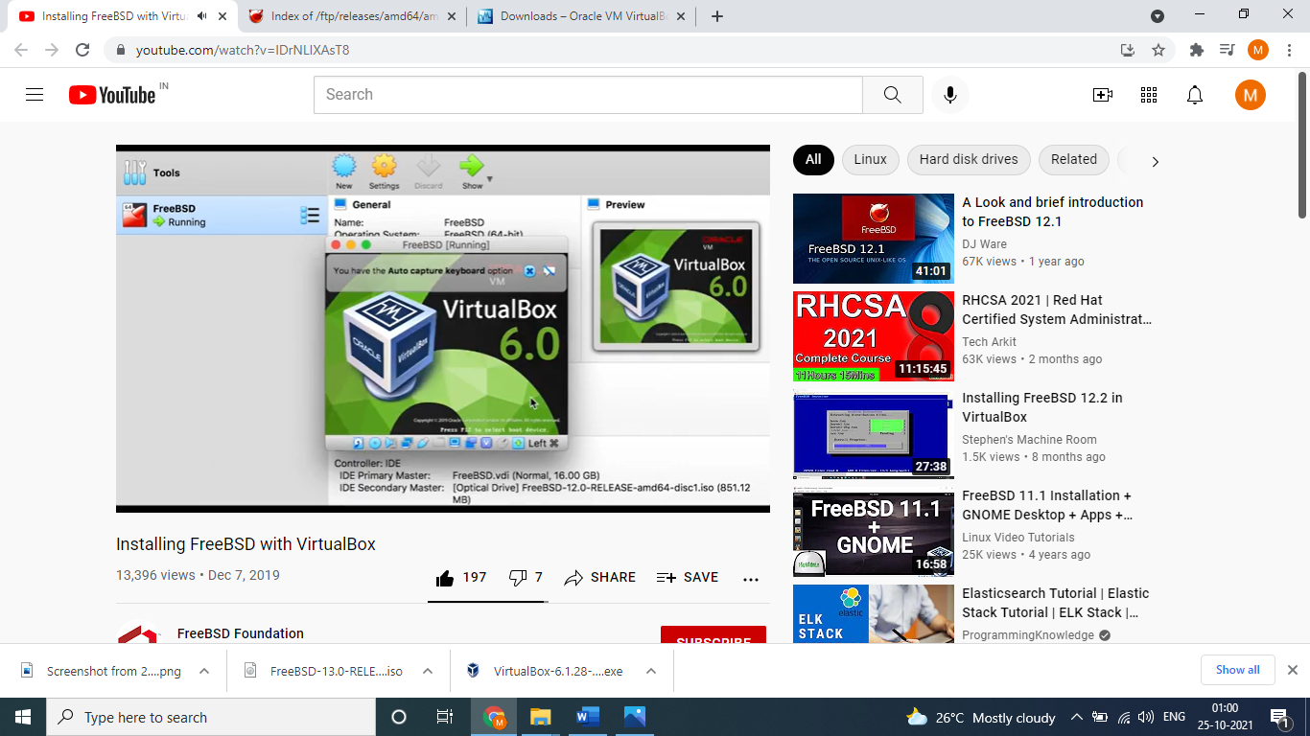

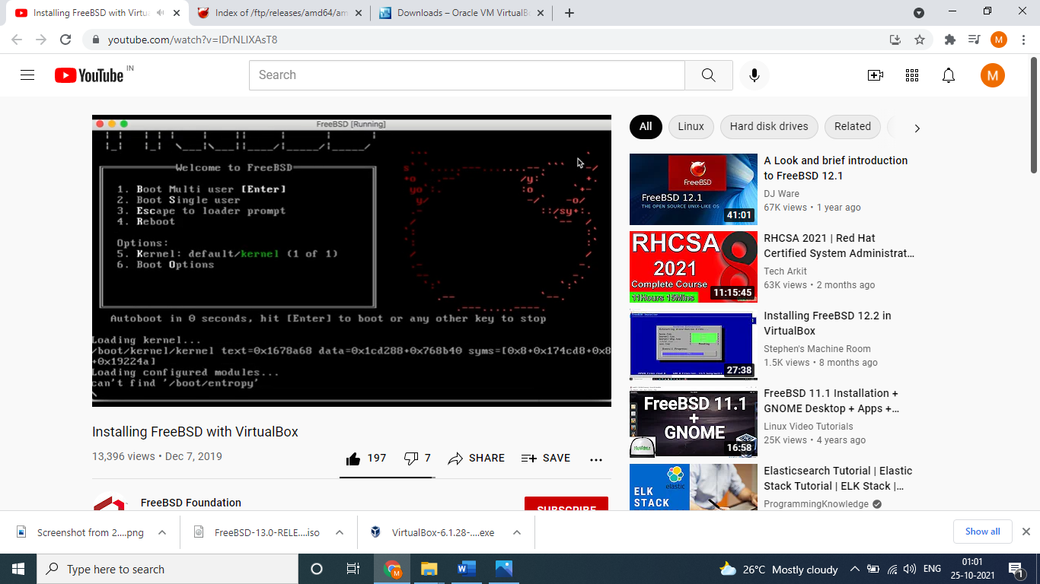

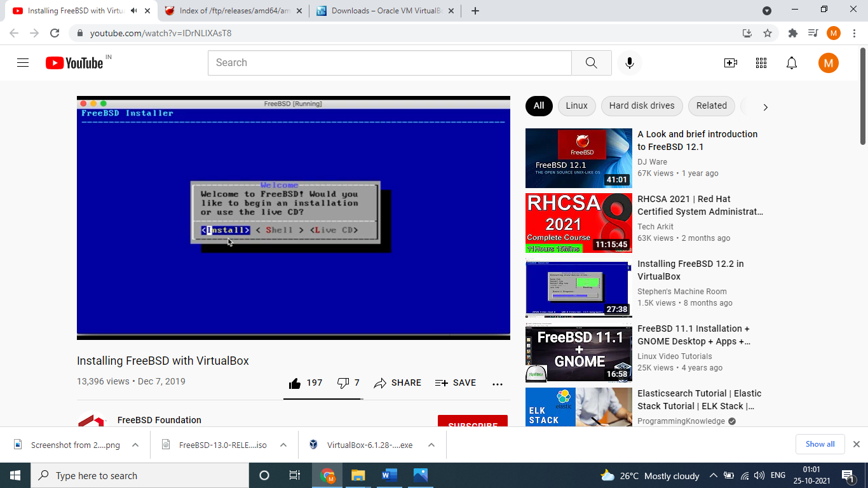

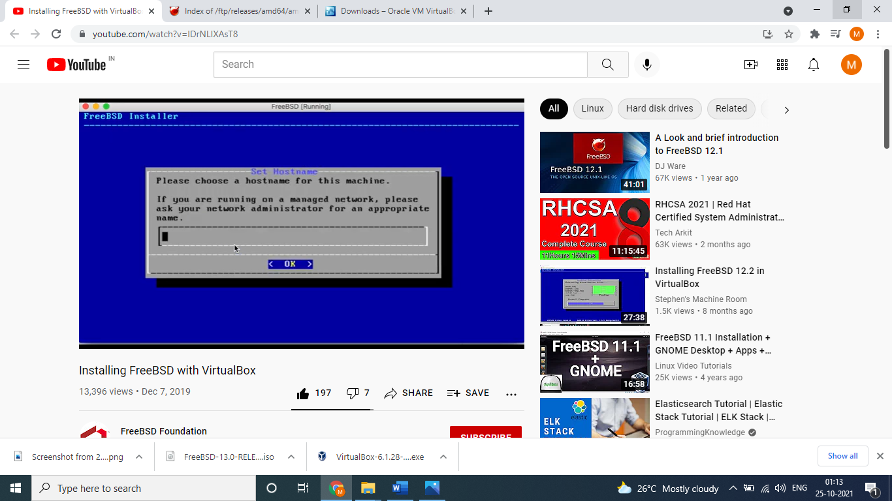

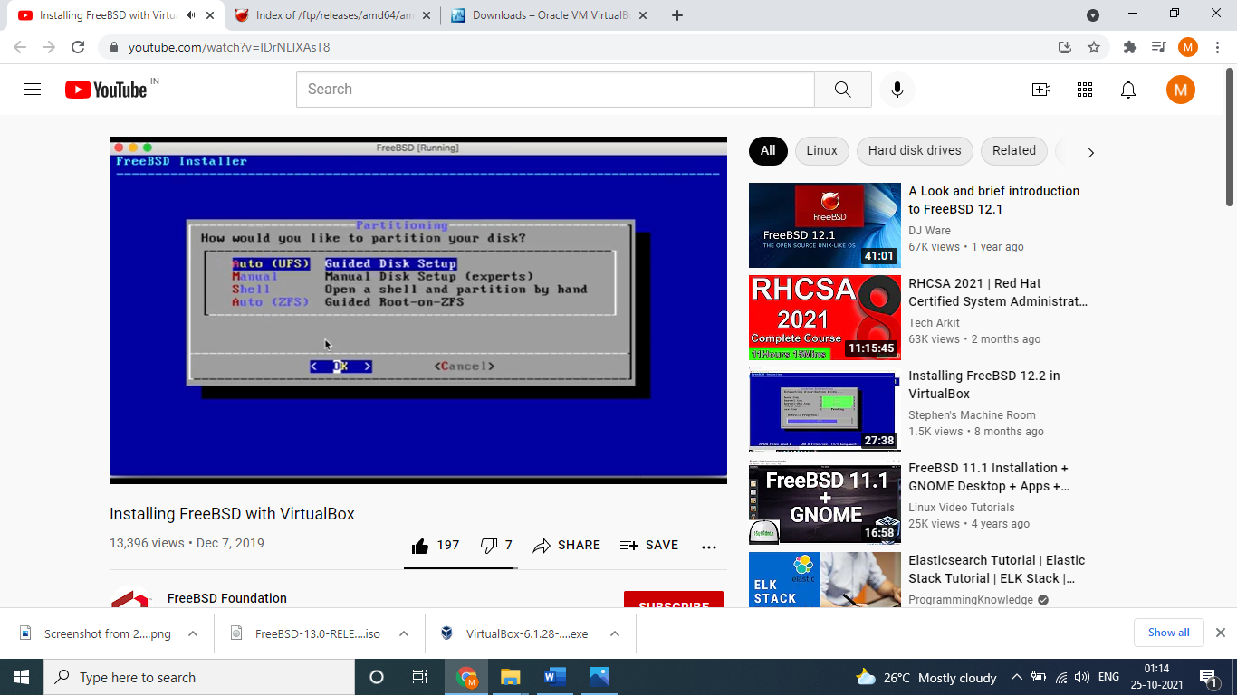

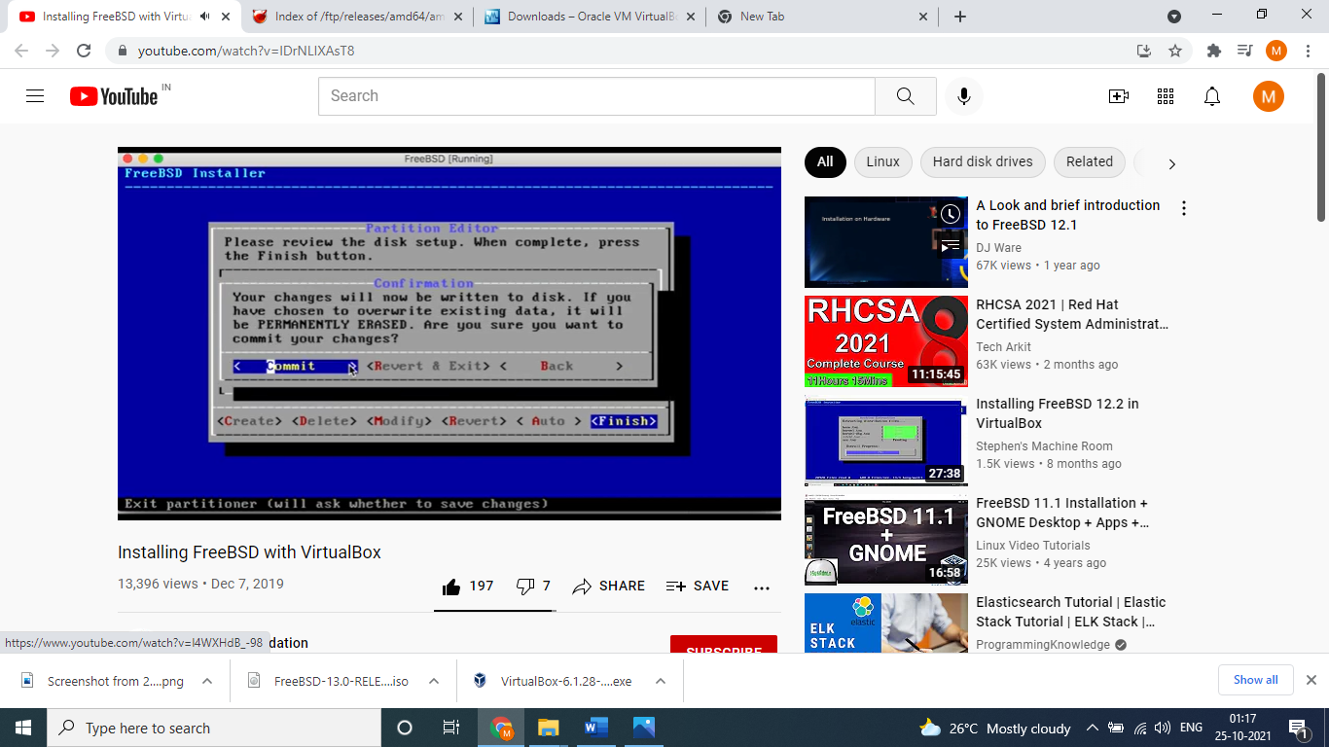

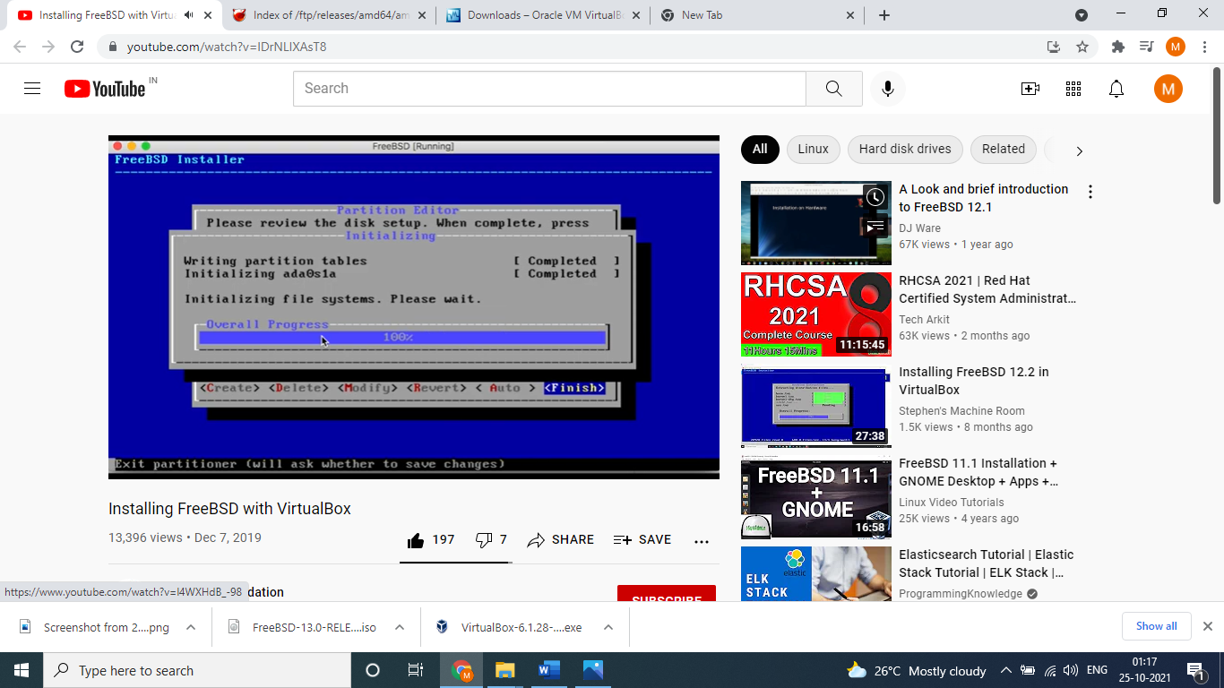

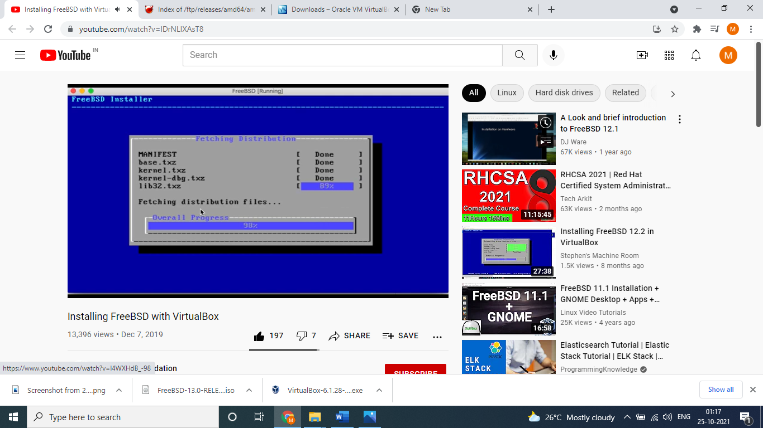

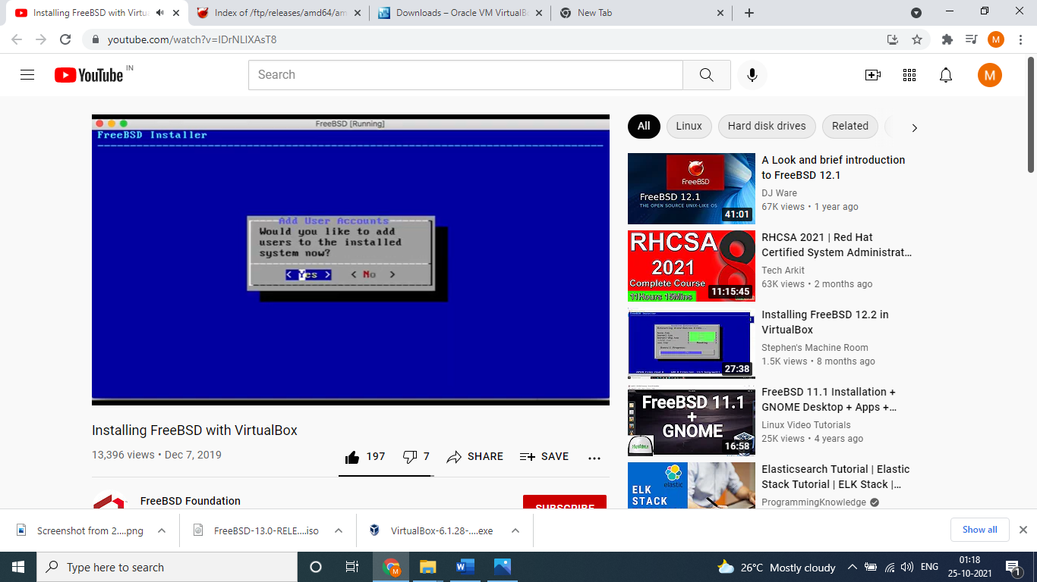

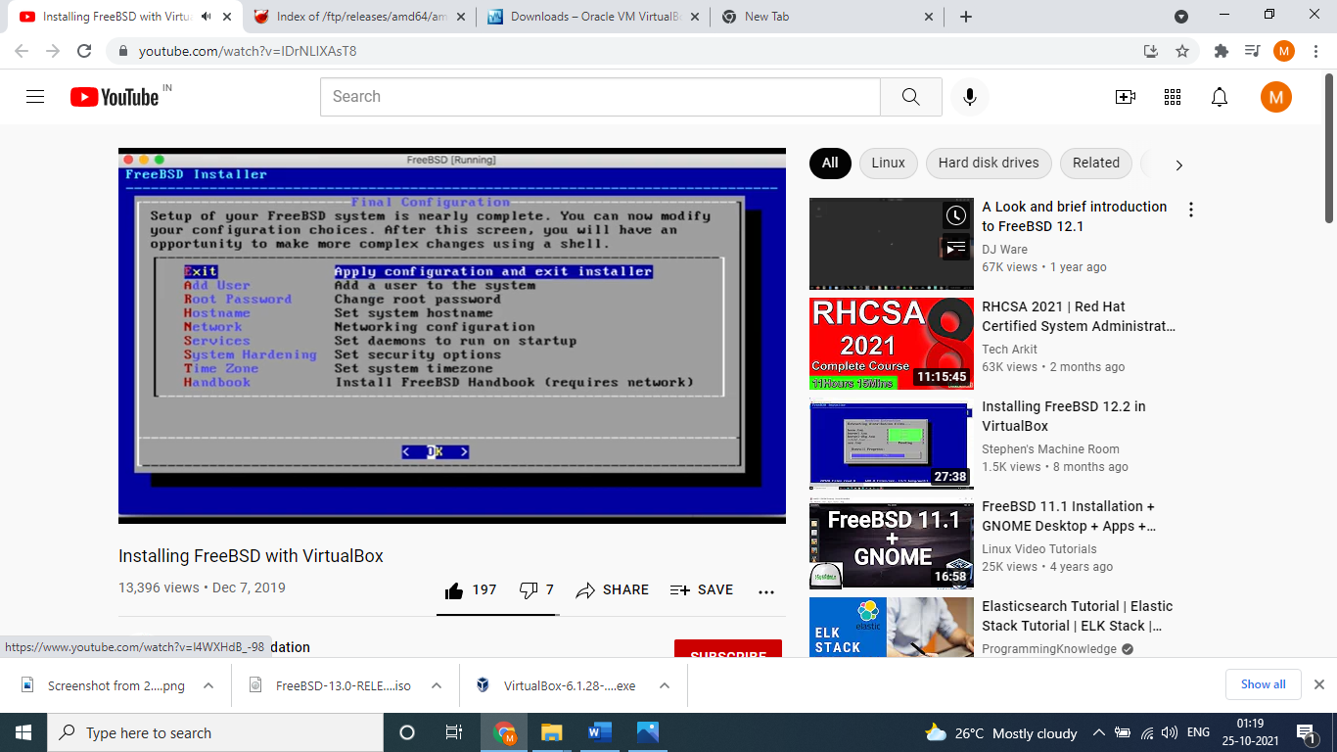

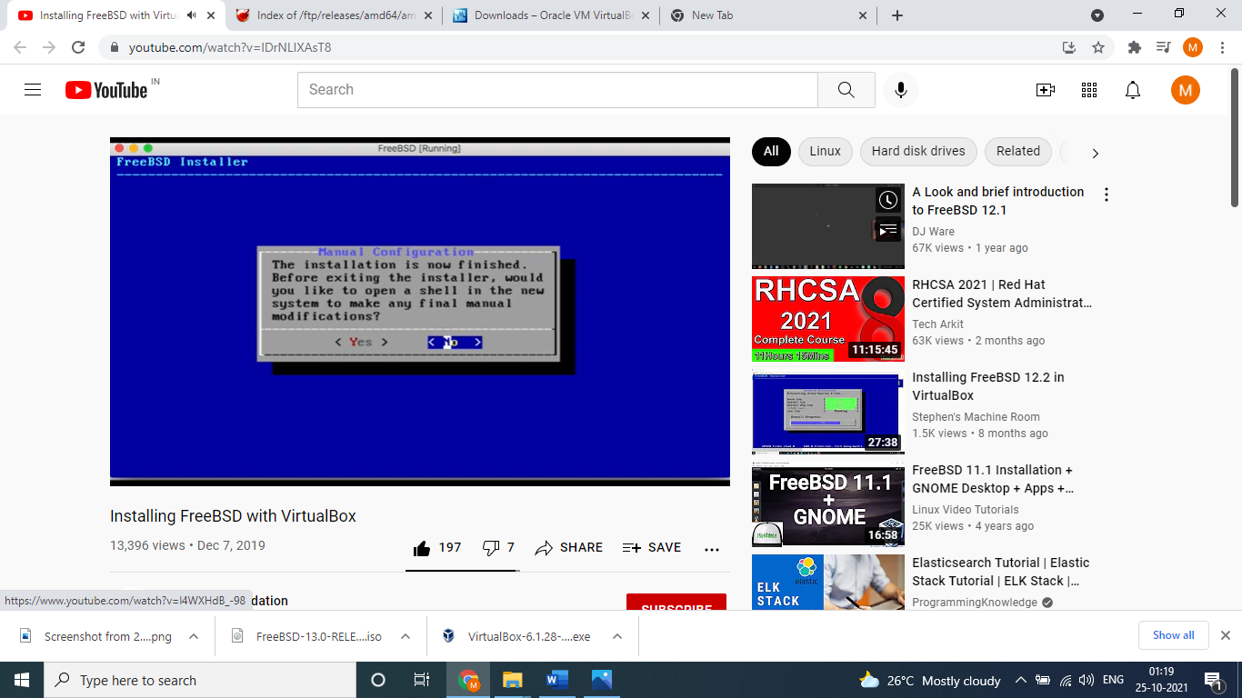

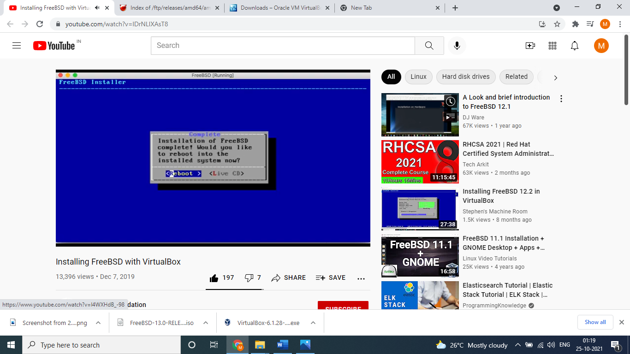

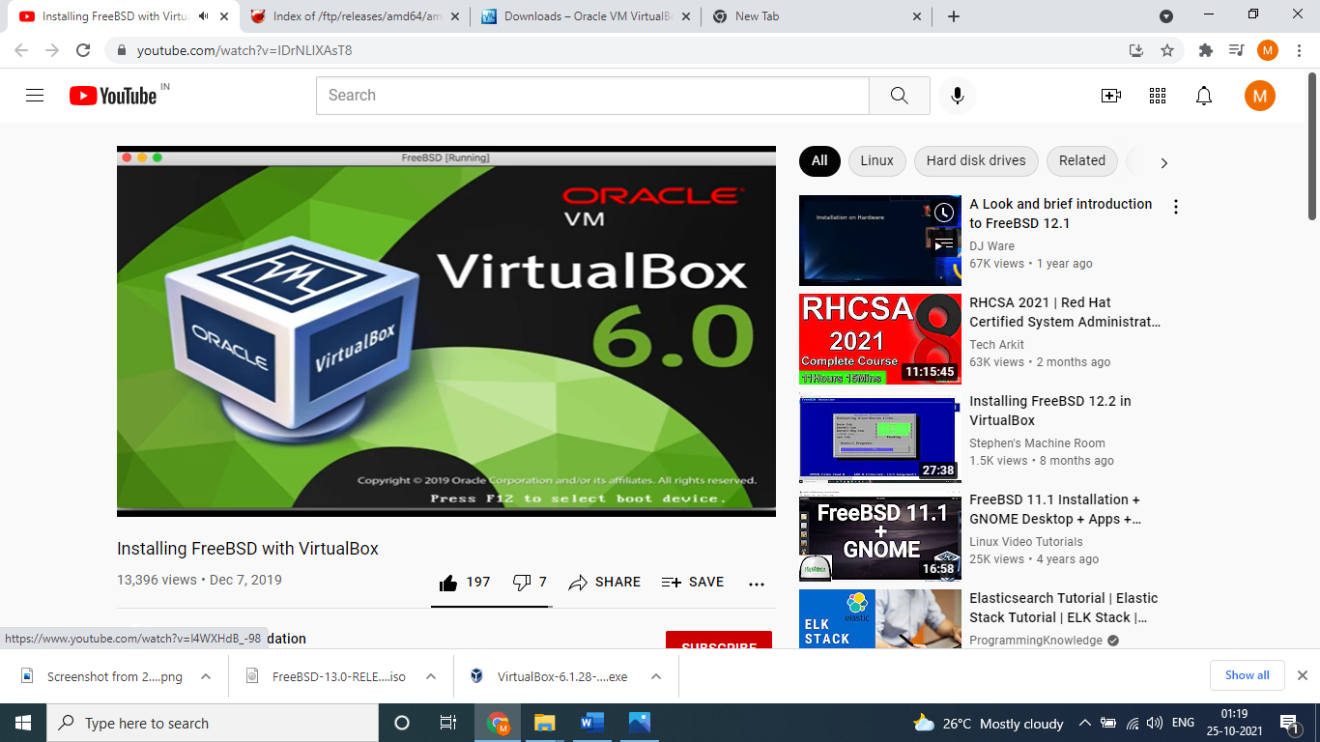

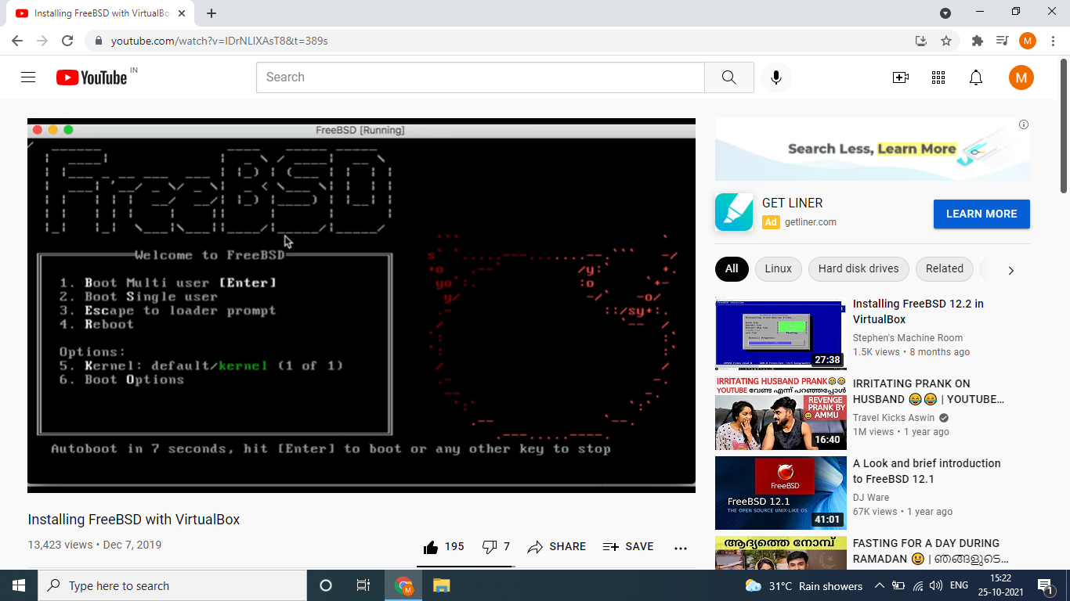

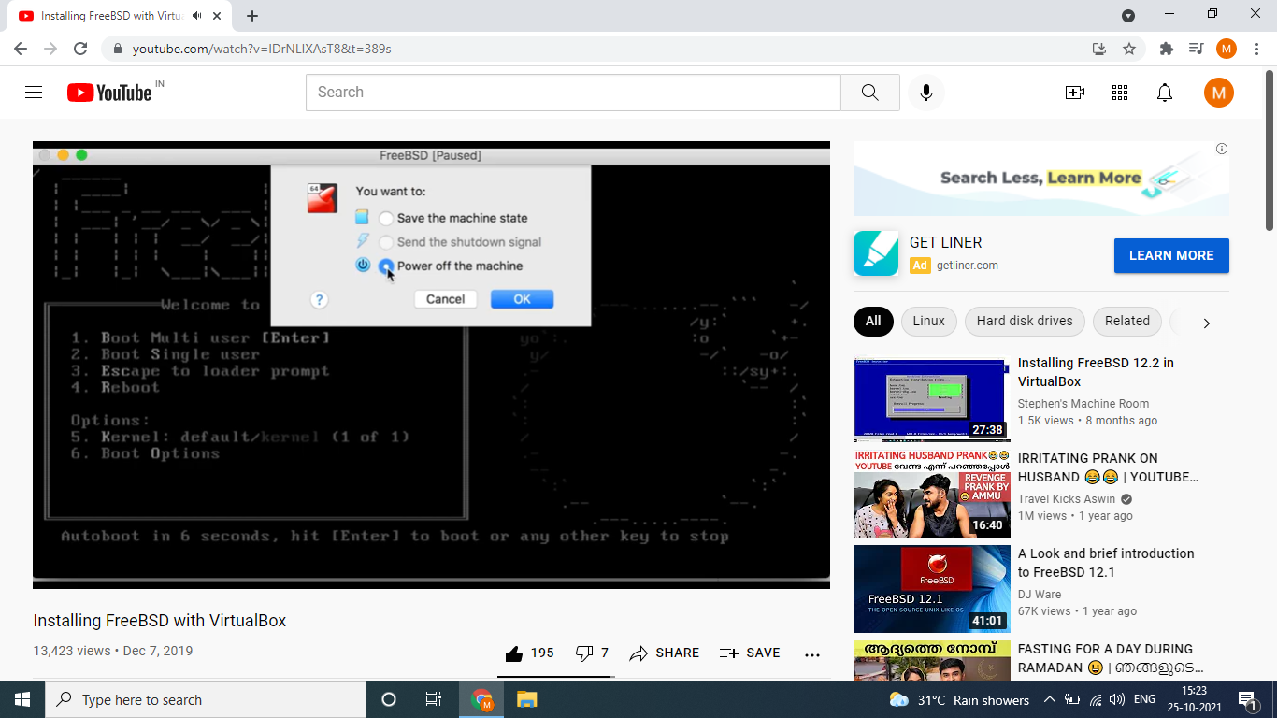

What is kernel and shell?

The kernel is the heart of the operating system. The term kernel often refers to the operating system. The critical code of the kernel is stored in a special memory area to protect it from other programs. It is a vital component as it is the basis for the proper functioning of the entire system. The kernel performs a variety of tasks including process management, managing hardware devices and handling interrupts. Furthermore, it performs memory management, file handling, and task scheduling. A system call is a request by a process to the kernel. The kernel manages these system calls and other resources.

Shell is the interface between user and kernel. It is a command-line interpreter and is the interface between the user and the kernel. The user can enter commands to the shell. Then it interprets the commands to perform the required task. Furthermore, it executes programs and shell scripts. A shell script is a set of commands. The user should follow the standard syntax to write commands to the shell. There are various types of shells. The Bourne shell (sh) is the most popular Unix shell. The default prompt of Bourne shell is $. The Korn shell (ksh) is backward compatible with the Bourne shell and includes many features of C shell. Bourne Again Shell (bash) is a free shell replacement for the Bourne shell. The Korn and Bourne Again Shell are supersets of Bourne shell. Furthermore, the C shell (csh) provides a few advantages over the Bourne shell. It provides history features and aliasing of commands. The default prompt of the C shell is %.

**3.What OS means?**

An operating system (OS) is the program that, after being initially loaded into the computer by a boot program, manages all of the other application programs in a computer. The application programs make use of the operating system by making requests for services through a defined application program interface (API). In addition, users can interact directly with the operating system through a user interface, such as a command-line interface (CLI) or a graphical UI (GUI). An operating system brings powerful benefits to computer software and software development. Without an operating system, every application would need to include its own UI, as well as the comprehensive code needed to handle all low-level functionality of the underlying computer, such as disk storage, network interfaces and so on. Considering the vast array of underlying hardware available, this would vastly bloat the size of every application and make software development impractical.

**4. What is the function of kernal and shell?**

FUNCTION OF KERNEL:

As we have seen above that kernel is the Engine of any Operating System, so all the vital functions should e controlled and managed by kernel itself. There are various tasks and functions of a kernel but some of the important are given below:

1. Resource allocation- The kernel's primary function is to manage the computer's resources and allow other programs to run and use these resources. These resources are- CPU, Memory and I/O devices.

2. Process Management- A process defines which memory portions the application can access. The main task of a kernel is to allow the execution of applications and support them with features such as hardware abstraction.  
To run an application, a kernel first set up an address space for the application, then loads the file containing the application's code into memory, then set up a stack for the program and branches to a given location inside the program, thus finally starting its execution.

3. Memory Management- The kernel has full access to the system's memory. It allows processes to safely access this memory as they require it. Virtual addressing helps kernel to create virtual partitions of memory in two disjointed areas, one is reserved for the kernel (kernael space) and the other for the applications (user space).

4. I/O Device Management- To perform useful functions, processes need access to the peripherals connected to the computer, which are controlled by the kernel through Device Drivers. A device driver is a computer program that enables the operating system to interact with a hardware device. It provides the operating system with information of how to control and communicate with a certain piece of hardware.  
A kernel maintains a list of available devices. A device manager first performs a scan on different hardware buses, such as Peripheral Component Interconnect (PCI) or Universal Serial Bus (USB), to detect installed devices, then searches for the appropriate drivers. The kernel provides the I/O to allow drivers to physically access their devices through some port or memory location.

5. Inter- Process Communication- Kernel provides methods for Synchronization and Communication between processes called Inter- Process Communication (IPC). There are various approaches of IPC say, semaphore, shared memory, message queue, pipe (or named fifo), etc.

6. Scheduling- In a Multitasking system, the kernel will give every program a slice of time and switch from process to process so quickly that it will appear to the user as if these processes were being executed simultaneously. The kernel uses Scheduling Algorithms to determine which process is running next and how much time it will be given. The algorithm sets priority among the processes.

7. System Calls and Interrupt Handling- A system call is a mechanism that is used by the application program to request a service from the operating system. System calls include close, open, read, wait and write. To access the services provided by the kernel we need to invoke the related kernel functions. Most kernels provide a C Library or an API, which in turn invokes the related kernel functions.  
There are few methods by which the respective kernel function can be invoked- using Software- Simulated Interrupt, or using a Gate Call, or by using a Special System Call Instruction and by using a Memory- based Queue.

8. Security or Protection Management- Kernel also provides protection from faults (error control) and from malicious behaviors (Security). One approach toward this can be Language based protection system, in which the kernel will only allow code to execute which has been produced by a trusted language compiler.

FUNCTION OF SHELL:

Shells provide a way for you to communicate with the operating system. This communication is carried out either interactively (input from the keyboard is acted upon immediately) or as a shell script. A shell script is a sequence of shell and operating system commands that is stored in a file.

When you log in to the system, the system locates the name of a shell program to execute. After it is executed, the shell displays a command prompt. This prompt is usually a $ (dollar sign). When you type a command at the prompt and press the Enter key, the shell evaluates the command and attempts to carry it out. Depending on your command instructions, the shell writes the command output to the screen or redirects the output. It then returns the command prompt and waits for you to type another command.